Experiment 5: Harmonic Oscillator, Part I. Spring Oscillator.

Amanda Wei

505 106 664

05/23/2019

Thursday 8am

Steve Mendoza

John Field

**Comparison of Damped and Undamped Harmonic Motion**

Amanda Wei1

**Abstract**

The goal of this experiment is to analyze the damped harmonic system in contrast to the undamped one. To that end, two trials were run, one in which no damping force was present, and the second in which there was an aluminum tube to provide the desired damping effect. When the mass was set into oscillation, a plot of force measured by the force sensor and time was created. As expected, the graph of the undamped trial had minimal, near negligible loss in amplitude, while the amplitude of the damped oscillation decreased by a near constant factor of about 0.890 $±$ 0.002 times the amplitude of the preceding peak. Both predicted and measured resonant frequencies were either measured or calculated for both trials. For the undamped oscillator, the resonant frequency was yielded $0.670±0.01 Hz$, and the damped system had resonance frequency $0.668±0.01 Hz$. Both measured values were found to be within 0.01 of the predicted value, and within $0.02±0.014 Hz$, suggesting that damping forces have little effect on frequency.

**1**Physics and Astronomy Department, University of California, Los Angeles.

**Introduction**

A mass on a spring in free harmonic oscillation ideally loses no energy to friction or heat, and the amplitude remains constant with time. This corresponds to a system modeled by a singular force influencing the motion of an undamped harmonic oscillator which is proportional to the displacement. However, under the influence of a damping force, a new term which is dependent on the velocity is introduced. Energy is lost to the surrounding environment, and the oscillator is no longer in simple harmonic motion. In this experiment, data was taken from both a freely oscillating system and a system with the addition of a damping force to observe how an applied damping force affects the period and frequency of the system. Using this data, we were able to determine the resonant frequency.

To accomplish this, the spring constant was determined first by plotting the gravitational forces exerted on several different masses against how much the mass was displaced from equilibrium. Next, we set the mass into oscillation and took data of the force sensor voltages and time, this time without a damping force. Then we used a long aluminum tube to create a damping force, the inductance within which is what we require to damp the oscillation of the mass.

Ultimately, the measured resonant frequency and predicted resonant frequency were observed to come within $0.001266±0.0014 Hz$ of each other. The differences in values may be attributed to systematic errors such as frictional loss in the oscillating spring. Using this data to derive a damping time and Q factor help quantify the loss in the damped oscillator.

**Methods**

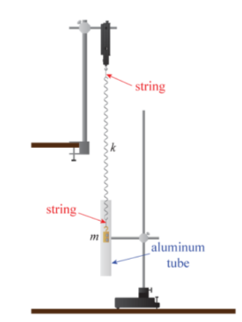

**Figure 1. Setup Schematic.2** In the trial of undamped harmonic motion, aluminum tube is removed. In measuring the motion of the damped harmonic oscillator, the motion of the magnets attached to the weight interacts with the tube to create eddy-current which impedes the motion of the mass. Notably, string is used to attach the spring to the force sensor, and also to attach the mass to the spring so the rotation of the mass from that of the spring.

The spring constant was determined first by measuring the displacement values as various masses were let to hang freely. A scatter plot was created, graphing the gravitational force experienced by the mass against the displacement measured. While previously displacement was measured as the difference between the mass’s position and its equilibrium position, the displacement was measured as the distance from the ground to the bottom of the mass. While the values are different, both are linearly related to the gravitational force experienced by the mass. Using the formula $F=-kx$, a line of best fit was created, and its slope is taken to be *k*, the spring constant.

Next, the DAQ is set up to record data of tension on the hook on the force sensor. from the force sensor, and this data is returned in terms of Voltage. Simultaneously, time stamps are recorded and the program is set up so both a table and scope display are shown. Because it is important to capture the maxima and minima of each oscillation, it is important to have the data recorded at high frequency so that the peaks are not missed. While the sample rate could be set to a value between 20 Hz and 50 Hz, for this experiment, the data was collected at 40 Hz, and in each trial, the mass was allowed to oscillate for thirty seconds.

The first trial was done for a mass under free oscillation. The mass is attached by string to the end of the spring, and the mass is pulled away from its equilibrium, and then allowed to oscillate freely for thirty seconds.

In the second trial, a long aluminum tube is placed below the oscillating mass. The mass is pulled up so that it does not surpass the height of the aluminum tube, and then released such that the mass does not touch the insides of the tube as it oscillates. Again, the mass is allowed to oscillate for thirty seconds.

**Analysis**

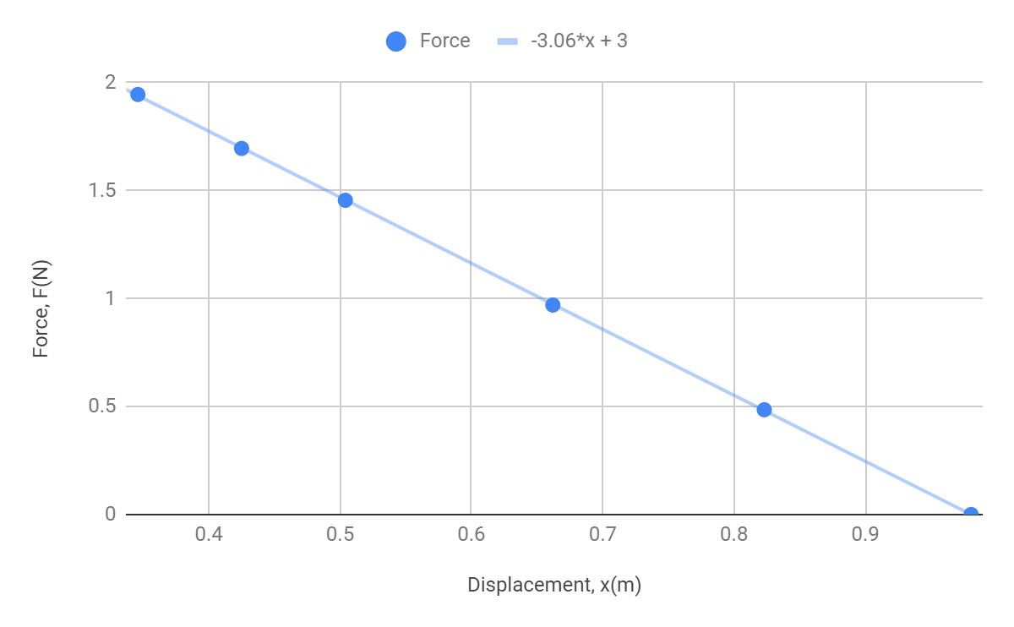

**Figure 2. Spring Constant Determination.** Each data point in this graph represents the mass *m* (49.5 g, 99 g, 148.5 g, 173 g, 198.5 g) multiplied by the gravitational constant plotted against the distance from the ground. Then, performing LINEST() on the list of displacement and force values, the line of best fit is represented by $y=-3.058x+2.998$, and hence the spring constant is determined to be: $k=3.058±0.007 N/m$.

Calculation of predicted resonant frequency, $f_{o}$:

$f_{o}=\frac{1}{2π}\sqrt{\frac{k}{m}}$

$k=3.058±0.007 N/m$, as determined from the data displayed in figure 2.

$m=0.173±0.0005 kg$

Best predicted resonance frequency value:

$f_{o}=$ $\frac{1}{2π}\sqrt{\frac{k}{m}}$ = $\frac{1}{2π}\sqrt{\frac{3.058}{0.173}}=0.669 Hz$

Uncertainty calculation for the resonant frequency:

$δf_{o}=\frac{1}{2π}|\frac{k}{m}|\sqrt{{(\frac{δk}{k})}^{2}+{(\frac{δm}{m})}^{2}}=\frac{1}{2π}|\frac{3.058}{0.173}|\sqrt{{(\frac{0.007}{3.058})}^{2}+{(\frac{0.0005}{0.173})}^{2}}=0.01 Hz$

Therefore, the predicted value is:

$f_{o, predicted}=0.669±0.01 Hz$

Undamped Oscillation:

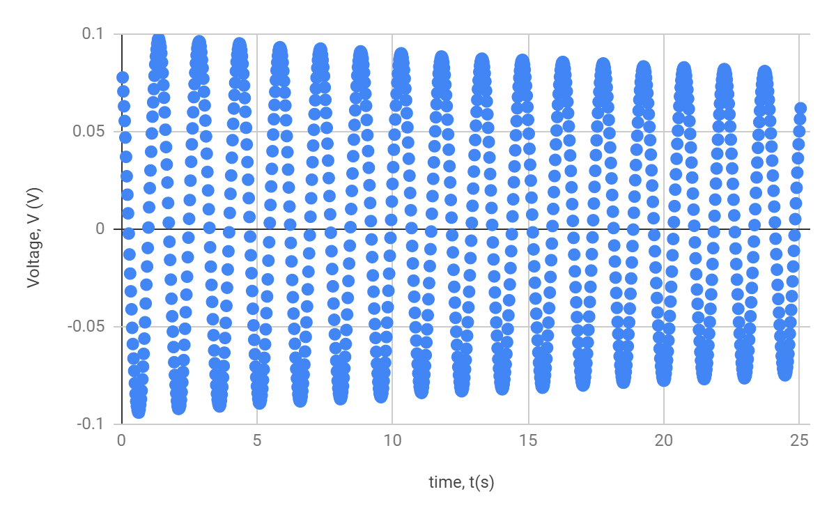

**Figure 3. Undamped Harmonic Motion Measurement.** Each data point is the voltage reading recorded at its respective time stamp.

To obtain a measurement of the resonance frequency from experimental data, the time values were taken between the first and fourth maxima, and divided by the number of peaks that occurred in between the time interval. The first peak occurs at 1.375 seconds, and the fourth peak occurs at 5.85 seconds. Then the period, which is the period of the wave, is given by:

$T=\frac{5.85-1.375}{4-1}=1.492±0.025 s$

The uncertainty in time is given by $δt=0.025s$, since the time data was collected at a rate of 40 Hz. So when the time value is inverted to obtain a value of frequency in *Hz,* the measured resonance frequency is:

$f_{o, measured}=\frac{1}{1.492}=0.670 Hz$

And the uncertainty is:

$δf_{o, measured}=f_{o, measured}\frac{δT}{T}=0.01 Hz$

Thus, the measured resonance frequency is:

$f_{o, measured}=0.670±0.01 Hz$

The difference between the predicted and measured resonance frequencies is:

$|f_{o, measured}-f_{o, predicted}|±\sqrt{{(δf_{o,measured})}^{2}+(δf_{o,predicted})^{2}}=0.001±0.01 Hz$

The difference between the predicted and measured values is less than the uncertainty in each, so it is not statistically significant.

Damped Oscillation:

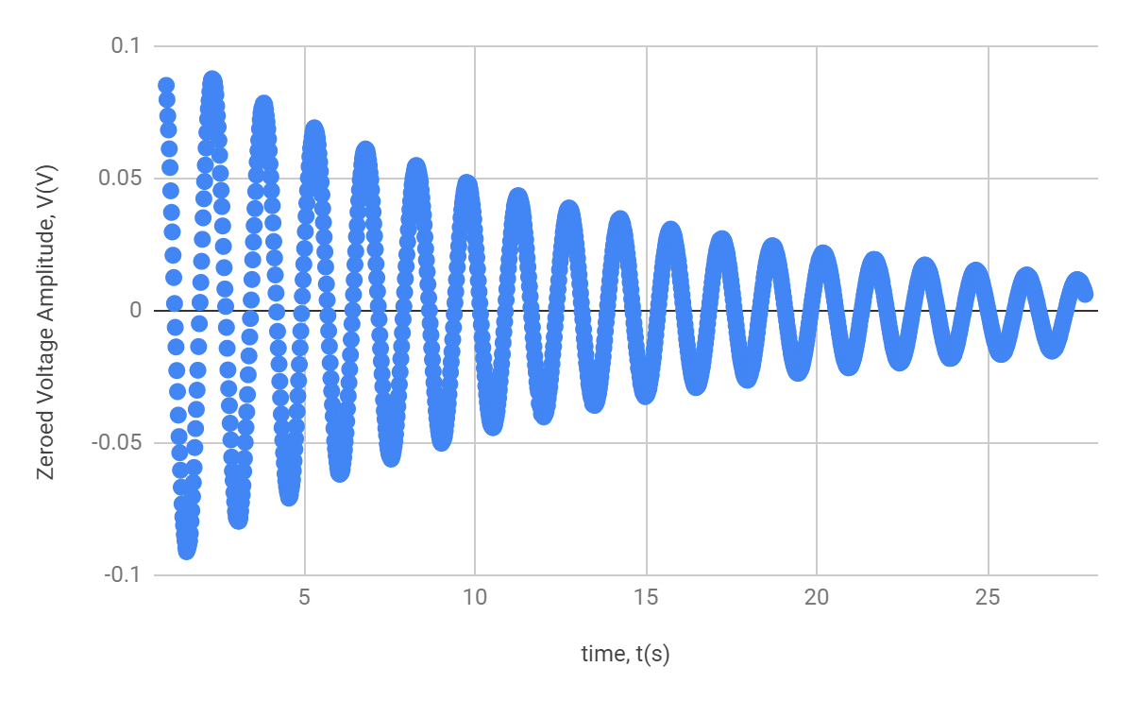

**Figure 4. Damped Harmonic Motion Measurement.** The data displayed here was collected the same way the data was collected in figure 3, except this time a damping force was added. In the raw data that was collected, there was some upward drift as time increased. To center the amplitudes around zero, LINEST() was performed on the raw data, and a line of best fit was created. Then, the line of best fit was subtracted from the amplitude values recorded by Capstone. The centered amplitude graph of damped harmonic motion is displayed here.

A value for $f_{damped}$ is obtained the same way $f_{o, measured}$ was obtained. The time stamps for two peaks are taken, the period is obtained, and then inverted to obtain the frequency. The first peak occurred at 2.31 seconds, and the fourth occurred at 6.798 seconds. So, the period is given by:

$T=\frac{6.798-2.31}{4-1}=1.496±0.025 s$

Where again, the uncertainty of 0.025 s is given by the rate at which data was collected.

So the frequency is given by:

$f_{damped}=\frac{1}{T}±|f_{damped}|\frac{δT}{T}=0.668±0.01 Hz$

Derivation of tau:

Beginning with the differential equation representing harmonic motion with the addition of a damping force,

$mẍ=-kx-bẋ$

A possible solution is: $x(t)=Ae^{iwt}$, where $x'(t)=iwAe^{iwt}$, and $x''(t)=-w^{2}Ae^{iwt}$

Then plugging in *x(t), x’(t) and x’’(t),* the equation becomes:

$-w^{2}Ae^{iwt}=-kAe^{iwt}-iwbAe^{iwt}$

Rearranging the terms and solving the quadratic equation for frequency,

$mw^{2}-ibw-k=0$, and $w^{2}-\frac{ib}{m}w-\frac{k}{m}=0$

Using the quadratic formula,

$w=\frac{\frac{ib}{m}±\sqrt{\frac{b^{2}}{m^{2}}-4(-\frac{k}{m})}}{2}=\frac{ib}{2m}±\sqrt{\frac{k}{m}-\frac{b^{2}}{4m^{2}}}$

Plugging this expression for frequency *w* back into *x(t),* we get:

$x(t)=Ae^{i(\frac{ib}{2m}±\sqrt{\frac{k}{m}-\frac{b^{2}}{4m^{2}}})t}=Ae^{i\sqrt{\frac{k}{m}-\frac{b^{2}}{4m^{2}}t}}e^{-bt/(2m)}$.

We introduce the term $τ≡\frac{2m}{b}$. This is the damping time, and is the amount of time it takes the undriven damped oscillator to decrease its amplitude by a factor of *e*.

Derivation of Q, k, m, b:

We are given that

$f_{damped}≡f_{o}\sqrt{1-\frac{1}{4Q^{2}}}=\frac{w_{damped}}{2π}$ = $\frac{1}{2π}\sqrt{\frac{k}{m}-\frac{b^{2}}{4m^{2}}}=f_{o}\sqrt{1-\frac{b^{2}}{4km}}$

Taking $f_{o}=\frac{1}{2π}\sqrt{\frac{k}{m}}$ and plugging in expressions for $w_{damped}$ and $τ$, the equation for *x(t)* can be rewritten as:

$x(t)=Ae^{iw_{damped}t}e^{(-t/τ)}$.

The first part of this expression tells us that the real part is a sine wave with oscillation of frequency $w_{damped}$, while the second tells us that the solution decays exponentially with time constant $τ$.

To derive an expression for Q, we return to the various expressions for $f_{damped}$:

$f_{damped}≡f_{o}\sqrt{1-\frac{1}{4Q^{2}}}=f_{o}\sqrt{1-\frac{b^{2}}{4km}}$, so

$\sqrt{1-\frac{1}{4Q^{2}}}=\sqrt{1-\frac{b^{2}}{4km}}$

Solving for Q,

$\frac{1}{4Q^{2}}=\frac{b^{2}}{4km}$

$Q^{2}=\frac{km}{b^{2}}$

And finally, $Q=\frac{\sqrt{km}}{b}$.

An alternative way of calculating tau for succeeding data is by using the formula:

$τ=-\frac{T}{ln|\frac{V(t+τ)}{V(t)}|}$.

A list of numbers is generated from this formula, and each number represents the damping time between two succeeding data points. The average value of these numbers is:

$τ=\frac{sm}{b}$ = 12.935 $±$ 0.2 s

Solving for other values,

$b=\frac{2m}{τ}$ = 0.0267 $±$ 0.001 kg/s

Substituting in values for k, m and Q= $\frac{\sqrt{km}}{b}±\sqrt{({\frac{δfo}{f_{o}})}^{2}+({\frac{δm}{m})}^{2}}=27.250±0.3$

Then using

$f_{damped}≡f_{o}\sqrt{1-\frac{1}{4Q^{2}}}=f_{o}\sqrt{1-\frac{b^{2}}{4km}}$,

$f_{damped}=0.67\sqrt{1-\frac{1}{4(27.250)^{2}}}=0.670±0.01 Hz$

This is the predicted value of $f_{damped}$, which is close to the predicted value of

$f_{measured}$ = $0.668±0.01 Hz$.

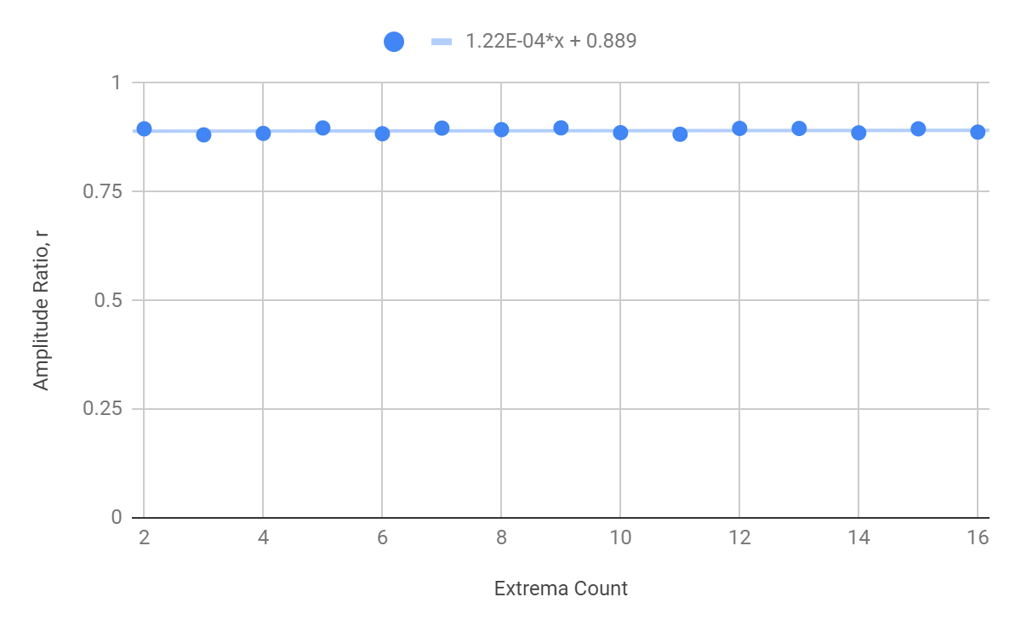**Figure 5. Ratio of Successive Amplitudes Chart.** The amplitudes are obtained from the peaks in the graph of damped harmonic motion, and are identified by the order in which they appear. Then the ratio of each amplitude and the successive amplitude is is obtained and displayed in this chart. The average ratio value between successive amplitudes is: 0.890, wich an uncertainty of about $±$ 0.0004, which comes from performing LINEST() on the array of ratio values.

**Conclusion**

The goal of this experiment was to compare the resonance frequencies of both damped and undamped systems. To that end, data of the motion of an oscillating spring-mass system was collected twice, once without the presence of the aluminum rod, and once with. The spring constant of the spring was determined first.

After collecting data, a predicted value of resonance frequency $f_{o,predicted}$ was calculated for, and a measured resonance frequency was determined to be. To describe the damped case, using the formula for resonance frequency gave $0.668±0.01 Hz$ for the measured frequency. Tau, the damping time, was calculated to be $τ=12.935±0.2$, and the quality factor of damped oscillation (Q) is $Q=27.250±0.3$. $τ$, along with Q, was then used to calculate the predicted damping frequency, which came out to be: $f_{damped}=0.0668±0.01 Hz$.

One source of systematic error is the drift that was evident in the graph of the raw data from the damped harmonic motion trial. To compensate for it, the slope of the line of best fit was determined to identify how the center deviated from zero. This was then subtracted from the raw data to produce a graph that is centered at zero, as shown in Figure 4. However, subtracting the line of best fit was only an approximation, and creates uncertainty. This error could be minimized by allowing the mass to hang on the spring for a few minutes before recording the data, using a spring with a greater spring constant, or quantifying how much drift appears for various masses and then taking a linear function which is then used to modify the raw data.

**Works Cited**

[2] Campbell, W.C. et al. Physics 4AL: Mechanics Lab Manual. UCLA Department of Physics and Astronomy. 64:64. 2018.